

National Textile University
Department of Computer Science
Subject:
Mobile App Development

Submitted to:
Sir Rehan Sarwar

Submitted by:
Ahsan Maqsood

Reg number:
1130

Lab no. :
01

Semester:

6th

Task 1 –
import 'package:flutter/material.dart';

class HomeScreen extends StatelessWidget {
const HomeScreen({super.key});
@override
Widget build(BuildContext context) {
return Scaffold(
appBar: AppBar(
title: const Text("Custom Cards Task"),
backgroundColor: Colors.blue,
),
backgroundColor: Colors.grey[200],
body: Padding(
padding: const EdgeInsets.all(16.0),
child: Column(
children: [

Card(
color: Colors.lightBlue,
elevation: 15,
child: Padding(
padding: const EdgeInsets.all(5),
child: Row(
mainAxisAlignment: MainAxisAlignment.spaceEvenly,
children: const [
Icon(Icons.home, size: 30, color: Colors.white),
Icon(Icons.star, size: 40, color: Colors.yellow),
Icon(Icons.settings, size: 35, color: Colors.black),
],
),
),
),
const SizedBox(height: 20),
Card(
color: Colors.green,
elevation: 10,
child: Padding(
padding: const EdgeInsets.all(20),
child: Row(
mainAxisAlignment: MainAxisAlignment.spaceBetween,
children: const [
Icon(Icons.favorite, size: 50, color: Colors.red),
SizedBox(height: 10),
Icon(Icons.thumb_up, size: 35, color: Colors.white),
SizedBox(height: 10),
Icon(Icons.message, size: 30, color: Colors.black),
],
),
),
),
const SizedBox(height: 20),
Card(
color: Colors.purple,
elevation: 15,
child: Padding(
padding: const EdgeInsets.all(20),
child: Row(
mainAxisAlignment: MainAxisAlignment.spaceAround,
children: const [
Icon(Icons.camera, size: 45, color: Colors.white),
Icon(Icons.music_note, size: 35, color: Colors.yellow),
Icon(Icons.phone, size: 30, color: Colors.green),
],
),
),
),
],
),
),
);
}
}

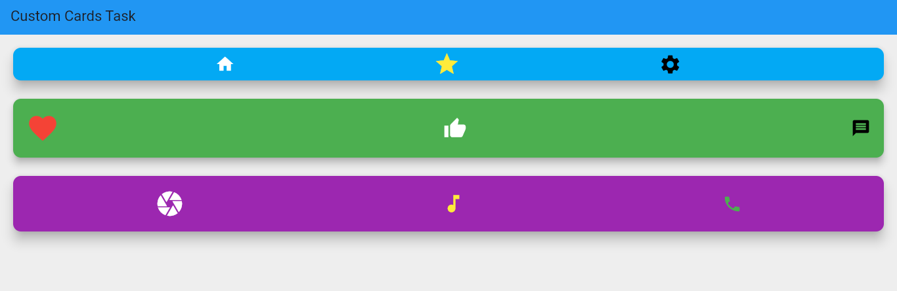
Task 2 –

import 'package:flutter/material.dart';

class SecHome extends StatelessWidget {
const SecHome({super.key});

@override
Widget build(BuildContext context) {
return Scaffold(
appBar: AppBar(
title: const Text("Margin & Padding Task"),
backgroundColor: Colors.blue,
),

body: Center(
child: Container(
margin: const EdgeInsets.symmetric(
vertical: 50.0,
horizontal: 10.0,
).add(
const EdgeInsets.only(left: 10),
),

padding: const EdgeInsets.all(20.0),
color: Colors.orange,
child: const Text(
"This is my Container",
style: TextStyle(fontSize: 18, color: Colors.white),
),
),
),
);
}
}
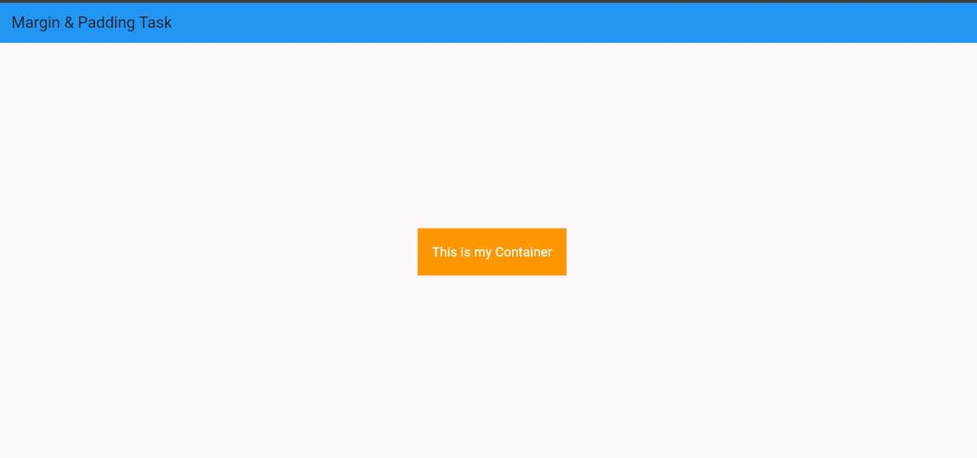

Task 3 –
import 'package:flutter/material.dart';

class CircularAvatar extends StatelessWidget {
const CircularAvatar({super.key});

@override
Widget build(BuildContext context) {
return Scaffold(
body: Center(
child: CircleAvatar(
radius: 50,
backgroundImage: AssetImage("assets/profile2.jpg"),
),
),
);
}
}

Task 4 –
import 'package:flutter/material.dart';

class InfoCardTask extends StatelessWidget {
const InfoCardTask({super.key});

@override
Widget build(BuildContext context) {
return Scaffold(
appBar: AppBar(
title: const Text("Card & ListTile Task"),
backgroundColor: Colors.blue,
),

body: Padding(
padding: const EdgeInsets.all(16),
child: Column(
children: [

Card(
elevation: 6,
shape: RoundedRectangleBorder(
borderRadius: BorderRadius.circular(15),
),
child: const ListTile(
leading: CircleAvatar(
backgroundColor: Colors.blue,
child: Icon(Icons.person, color: Colors.white),
),
title: Text(
"Ahsan maqsood",
style: TextStyle(fontWeight: FontWeight.bold),
),
subtitle: Text("Registration No: 1130"),
),
),

const SizedBox(height: 20),

Card(
color: Colors.green.shade50,
elevation: 10,
shape: RoundedRectangleBorder(
borderRadius: BorderRadius.circular(20),
),
child: ListTile(
leading: const Icon(
Icons.school,
color: Colors.green,
size: 35,
),
title: const Text(
"ahsan ali",
style: TextStyle(
fontWeight: FontWeight.bold,
color: Colors.green,
),
),
subtitle: const Text("Registration No: 1131"),
trailing: const Icon(
Icons.arrow_forward_ios,
color: Colors.green,
),
),
),
],
),
),
);
}
}

